Practical 13: PHP JSON API and AJAX/Fetch-Based CRUD without Page Reload
Problem Definition
Create simple PHP JSON API endpoints for events or students and consume them using Fetch API. Perform list, add, update, and delete operations asynchronously without full page reload.
A. Theory
1. Do PHP endpoints return valid JSON responses?
Answer: Yes. PHP endpoints return valid JSON responses that can be processed by the frontend.
2. Are GET and POST requests handled properly?
Answer: Yes. GET requests are used to retrieve data, while POST requests are used to send data to the PHP endpoints.
3. Are loading, success, and error states shown on the frontend?
Answer: Yes. The frontend displays loading, success, and error messages based on the API response.
4. Is input validation performed before database operations?
Answer: Yes. User input is validated before performing database operations to prevent invalid data from being stored.
B. Implementation / Output / Result
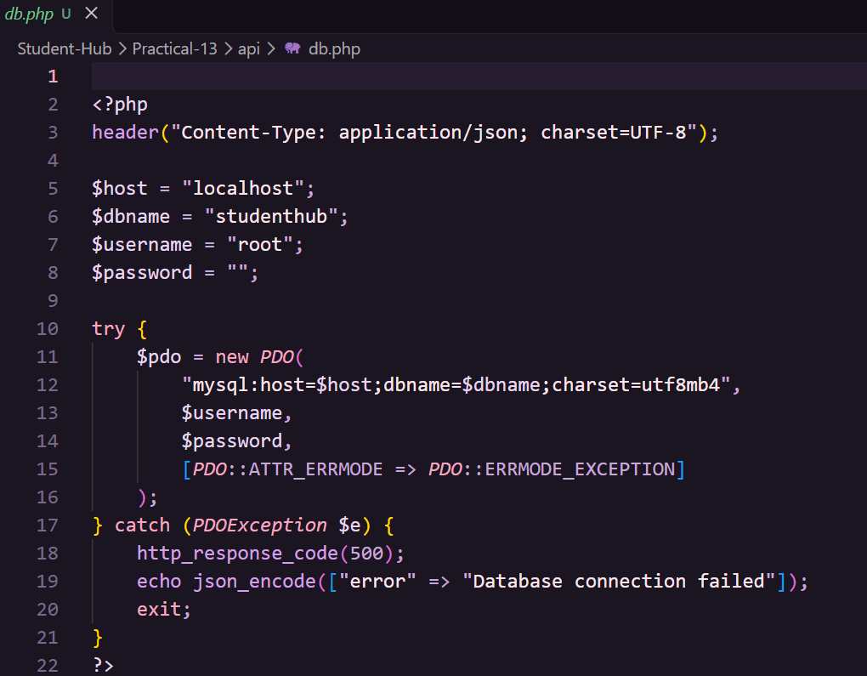
C. Evidence of Work (Screenshots)
Read:
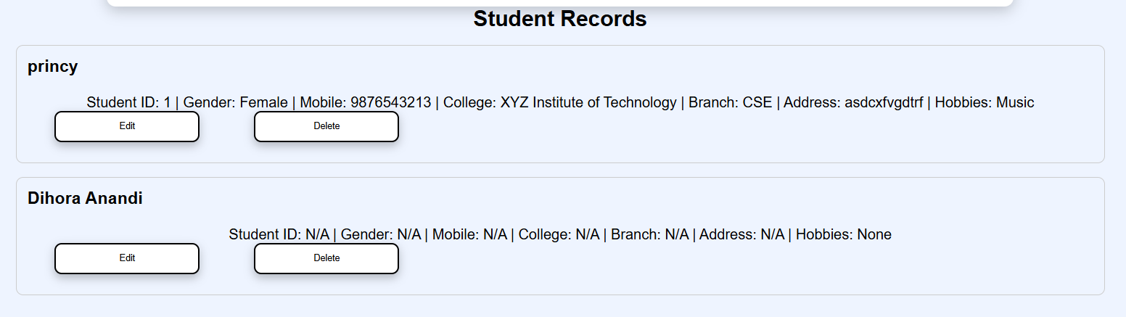
Create:
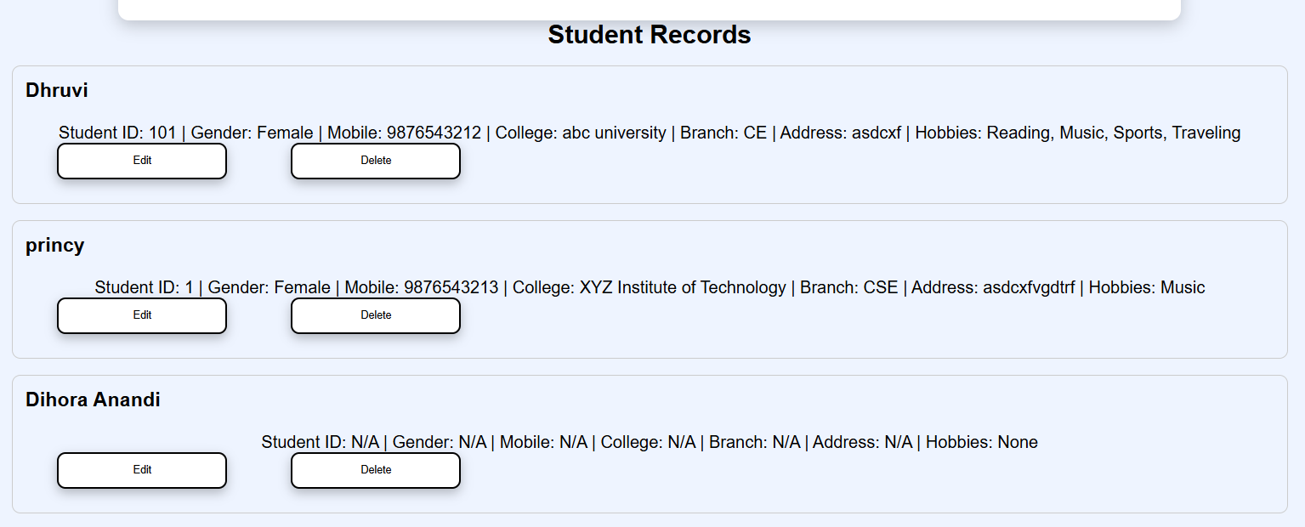
Update:
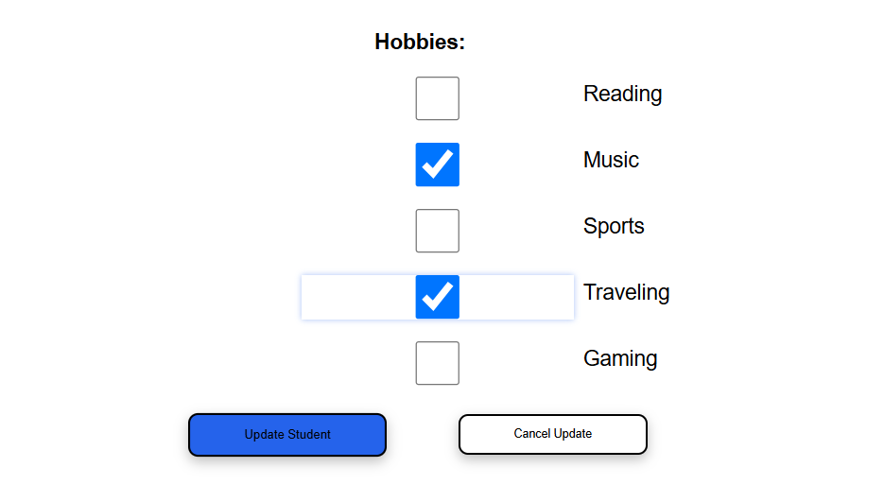
Delete:
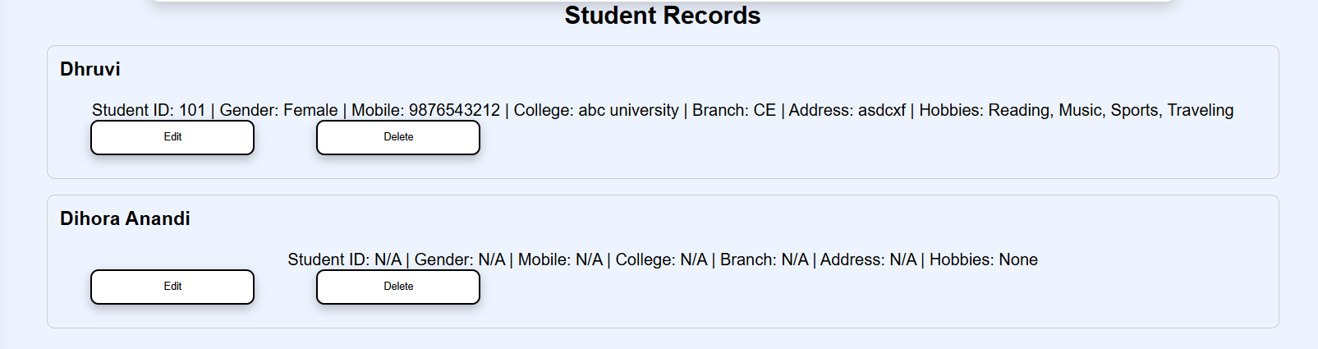
D. GitHub Repository Link
https://github.com/AD-9218/Student-Hub/tree/main/Practical-13/api
E. Challenges Faced
The main challenges faced during Practical-13 were connecting the PHP API to the MySQL database, resolving the undefined $pdo error, integrating the Fetch API with the frontend, displaying student records, and implementing CRUD operations without page reload. These issues were resolved by correcting the database connection and JavaScript Fetch API code.
F. Learning Outcomes
Students will learn to integrate frontend JavaScript with a PHP backend using JSON APIs and Fetch API to perform CRUD operations (Create, Read, Update, and Delete) asynchronously without reloading the webpage.
Faculty Remarks:

